**Java 9 Latest Features**

**First let’s find what are the enhanced features is available up to java 9 means let’s point out features of java 7 and java 8**

**Java 7 features:**

1. Try with resources
2. Multi Catch block
3. Diamond operator
4. String switch case
5. Underscore numeric literal
6. Fork join framework
7. Java NIO 2.0
8. G1 garbage collector

**Java 8 features:**

1. Lambda expression
2. Functional interface
3. Stream API
4. Default and static method in interface
5. Time API
6. Concurrency API improvement

Now let’s come to our discussion about Java 9 and its new features

**Java 9 features:**

1. Jshell (Java Shell)
2. JPMS (Java platform module system)
3. JLINK
4. Process API Updates
5. HTTP/2 Client
6. Try with Resources enhancement
7. Factory method for creating unmodifiable list
8. Private method in interface
9. G1 Garbage collector (it is default in java 9)

**Let’s discuss one by one with sample example**

1. **JSHELL:**

The use of this tool tools can greatly help in trying out new ideas and techniques and in quickly testing code without needing to write an entire test class to run.

This concept is not new already it available in python, Scala and in other technology now in java 9 it just adopted by java language

Same syntax which we can write in our IDE same we can do in JSHELL script

As far I understand the main moto of this tool in real time is developers can check there business logic quickly to check whether functionality is working or not

For Ex:

Assume I have a public method who contains business logic, to execute that logic as per SRS I write some data manipulation logic inside private method and calling that private method from public method.

So now if I want to check whether my private method is working or not what should I do I need to start my application and I can check by debug from that public method, but can’t check directly from private method.

Which we can do using JSHELL, we can test our small snippet of code directly instead of run fully business (test case and method)

Example:

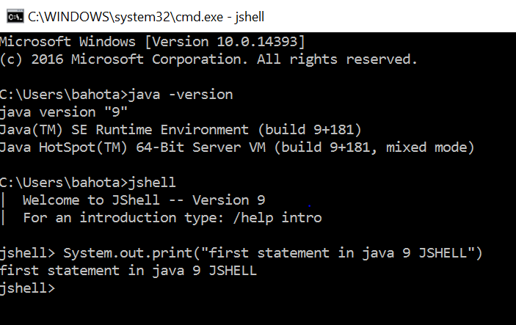

**Use Case:**

I will show how to test only specific method who contains secondary logic in jshell

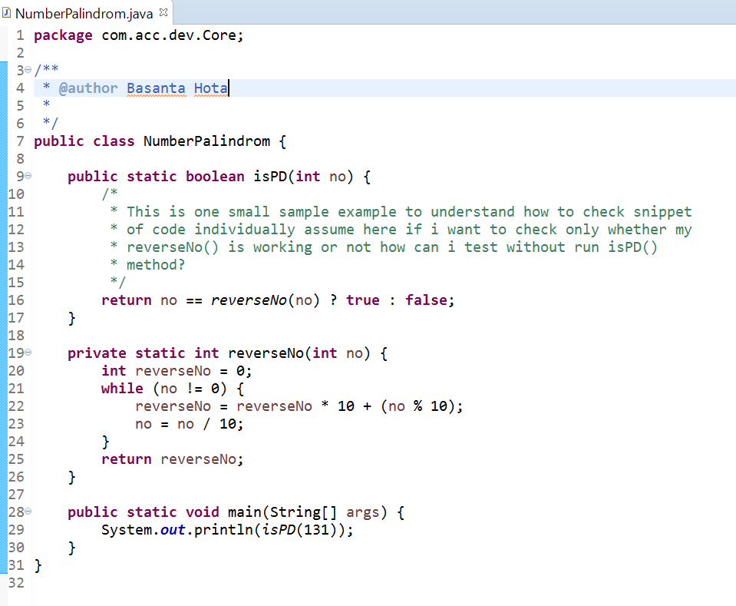

Testing from Jshell below snippet of code who contains secondary logic

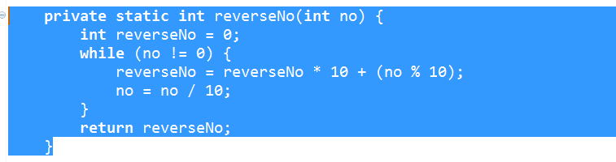

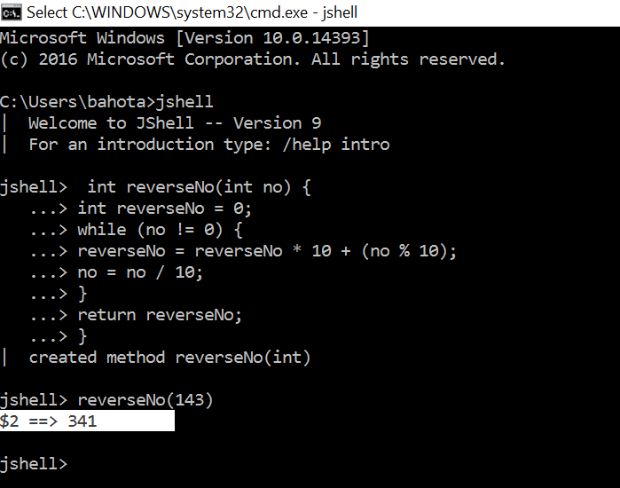

Working properly, so this is the way we can check quickly instead of run entire application